Chapter 7, Solution 79.

In the circuit in Fig. 7.143, the switch has been in position 1 for a long time but moves instantaneously to position 2 at t = 0. Determine i₀(t).

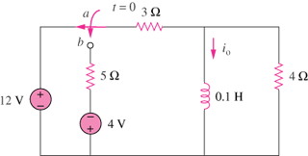

Figure 7.143
For Prob. 7.79.

Solution

When the switch is in position 1, i_{o}(0) = 12/3 = 4A. When the switch is in position 2,

